CST3180 UX Design CW1 Phase 1 User Research

Group B3

|  |  |
| --- | --- |
| Student Number | Student Name |
| M00804927 | Genna Tshifunda Simos |
| M00801926 | Abdullahi Mohamed |
| M00956393 | Muhammed Okunmoyinbo |
| M00985166 | Abdul Shodunke |
| M00899746 | Tianhao Hu |

Report Structure: 2000 words maximum

1. Problem definition (5%)

The increasing desire for greater convenience, energy efficiency, and security in contemporary living spaces is the driving force behind the need for smart homes. Smart technology integration can address the inefficiencies and irritations caused by traditional homes' incapacity to efficiently handle and regulate various aspects of daily life. The integration of smart technologies in homes will make it easier to manage and monitor appliances, security systems, and utilities, resulting in a more streamlined and convenient lifestyle. While conducting research for our project, a comprehensive and multi-faceted approach was employed to ensure a thorough understanding of the user’s needs, preferences, and any interactions they encountered with the technology. A combination of qualitative and quantitative research methods was used. Surveys were distributed to a diverse user base of ten people, to collect quantitative data on usage patterns, preferences, and satisfaction levels ***(see Appendix E and F)***.

2. Expert Evaluation of an existing similar system (15%)

**Amazon Echo (4th Gen)**

**Benefits:**

· Message, contact, and manage smart home appliances with capabilities that prioritise user experience.

· Versatile functionality: Provides music, news, sports scores, information, and weather updates while seamlessly connecting to the Alexa speech service.

· Excellent sound projection over a distance and an integrated smart home hub.

**Limitations**

· Sound Quality Limitation: A reduced frequency range generally results in less-than-ideal sound quality.

· Complexity of Smart Home Hub: The complete use for users may be limited by the possible difficulties of using the integrated smart home hub without prior knowledge.

**Use of Usability Heuristics:**

· Visibility of System Status: Echo's prompt response to user interaction demonstrates its responsiveness and provides appropriate feedback.

· Match between system and real world: Echo is more user-friendly because of its human-like answers.

· User Control and Freedom: giving users the ability to control all calls and interactions.

**Overall Assessment**

With its many features, the fourth generation Amazon Echo facilitates information access, home control, and conversation. Despite this, consumers may not fully utilise the smart hub due to its intricacy, but it is still a sought-after product because of its overall worth and an affordable price. Overall, it is an in-demand product and has great value for the price the customers are paying.

**3. Data gathering methods used (e.g. Interview, focus group, observation etc.) (do not forget to mention Triangulation) (20%)**

The data gathering method we decided to pick was a multi-point rating scale questionnaire since it was a good way of collecting data of people all at once, it also allowed us to get additional reasoning from students on our questions revolving around smart home technology. We collected ten consistent people to participate in the questionnaire.

Questionnaires give respondents a structured framework within which to choose their own answers by providing standardised response options. This makes it easier to analyse and compare responses, ensures consistency, and removes ambiguity. Standardised responses facilitate the quantitative measurement and classification of data by us researchers, thereby facilitating the identification of patterns, trends, and interrelationships among variables.

In our case, we incorporated a scale where the respondents were asked to rate our questions, and with their corresponding numbers, we were able to place their numbers on the scale, an example we used being “Likely” and “Not Likely”. By using standardised response options, the questionnaire collects consistent and quantifiable data that can be statistically analysed to measure overall customer answers, identify gaps in the market, or compare similarity levels across the different questions we had for the respondents.

Through the Triangulation method, we were able to use multiple methods/techniques such as, qualitative vs quantitative in the qualitative research to develop a comprehensive understanding of case study. With the help of the triangulation method, we were able to confirm our findings, we were able to produce consistent results, which allowed us to gain confidence in the end results of our questionnaire, since they all had a similar pattern.

**4. Analysis of gathered data – Requirements Specification, Behavioural Variables Mapping, User Stories, Personas, User Journeys, UXI Matrix etc. (40%)**

The initial phase requires a detailed analysis of the data that has been collected.

Firstly, the **requirements specification** is an outline of the project vision, specifying the system functionality, constraints and key elements. Ensuring a full understanding of the project objectives focuses on an in-depth analysis of these requirements. By reviewing and analysing each user requirement, we can specify that it is clear and actionable, providing a solid foundation for subsequent phases.

The user requirements for students in relation to our personas are:

* **Affordability**, since most students often have limited budgets, a cost-effective solution is crucial.
* **Compatibility**, since most students use different devices such as smartphones, laptops or iPads, the smart home devices need to be compatible.
* **Integrated with Study Environment**, students would want devices that enhances their study environment, such as smart lightening for adjustable brightness or smart speakers for voice-controlled reminders.

The user requirements for parents in relation to our personas are:

* **Home** **Security**, where the parents would want smart home security systems, including cameras, door/window sensors, and smart locks for enhancing home security.
* **Child Safety,** parents would want to consider smart home devices that enhances child safety, such as smart door locks, baby monitors, and smart lightening for night-time visibility.
* **Easy to Use,** since most parents prioritise devices with user-friendly interfaces, some may not have as much time to invest in complex setups.

**Behavioural variable mapping** maps multiple aspects of user behaviour to user interactions. Through in-depth analysis of these mappings, we can analyse and identify patterns in user behaviour, and identify potential problems and improvement points to optimise the user experience. This helps to improve user fluency and satisfy user needs.

In relation to smart home devices, behavioural variable mapping allows us to map users’ behaviours with their homes to optimise the performance and interactions they have with smart devices. By looking at ***Appendix E****,* we understood that the behavioural mapping helps us in identifying and understanding patterns of ten people we interviewed, so that we as the researchers, were able to recognise the trends and correlations that contributed to the certain questions. This can also allow us to identify factors that can influence a customer’s purchasing decision, so that it can be tailored to their requirements. An example would be that there’s a more likely percentage of users thinking smart home devices would improve their daily life routine as opposed to users who think it’s not likely ***(Appendix E).***

**User stories** are short narratives that describe the functionality of a system from the perspective of the user or customer. Each user story is analysed in detail to ensure that the user's needs are accurately understood and met ***(see Appendix C and D)***.

**Personas** and **user journeys** provide a panoramic view of the user profile and user experience. By analysing the relevance and completeness of personas, it is possible to ensure that these user personas accurately represent the system's diverse user base.

**Personas**, which are fictional characters created to represent different user types within a target audience, is a fundamental tool in user centred design, which helps us understand the audience’s needs, and goals. We created two persona, one which is the primary persona ***(see Appendix A)*** and a secondary persona ***(see Appendix B)*** so that we can prioritise and address the needs of the different groups effectively. The adult persona being the primary persona may have more decision-making authority and financial control within a household, so they will most likely responsible for purchasing and setting up the smart home devices. Whereas the secondary persona being the student will often have a limited budget, so cost-effectiveness is a crucial consideration. They may, however, be more interested in affordable and value-driven smart home solutions. By having both personas, will allow for features to be prioritised based on the specific needs of each persona. For example, security features might be more critical for the adult persona, while cost-effectiveness and efficiency might be more important for the student persona.

**User** **journey** diagrams identify the key steps in a user's interaction with the system, thus identifying areas for improvement ***(see Appendix J and K).*** By mapping out the user journey, it became more easier to identify frustrations, pain points, and areas where users may encounter difficulties,

Finally, the **UXI Matrix** is a tool for assessing the impact of different features on the overall user experience. Through in-depth analysis of the matrix, the features that have the greatest impact on the user experience are analysed and prioritised for optimisation ***(see Appendix I)***.

5. Discussion on what went well and how you would improve the method (5%)

**What went Well:**

We collaborated and executed ideas well, including them into our work report and mood board. Throughout the weeks we had an open communication and understanding that our frequent lab sessions promoted among team members, everyone was able to remain focused and determined to finish our coursework. Using Miro for documentation turned out to be beneficial and helped us have a placeholder for our work, made it easier to collaborate from anywhere, and greatly improved task delegation and remote productivity.

**How would we improve the method:**

Our group could have improved by communicating outside of lab sessions to improve our project approach. Frequent weekly Zoom meetings to discuss project development may have greatly improved the calibre of our group's output. A set meeting schedule would have encouraged more discipline and organised work, which might have improved the project's result. The approach to data collecting only 10 responses for behaviour variables ***(Appendix E)***, left us with minimal findings, and all replies were of similar age that led to the same answers, going forward we can expand our demographic and include a wider range of age groups. This can produce more thorough and varied results that can impact the scope of the project positively.

7. Appendices (5%) • Ethical Approval Request form • Copies of signed consent forms • Interview transcripts, questionnaires etc

Appendix A:

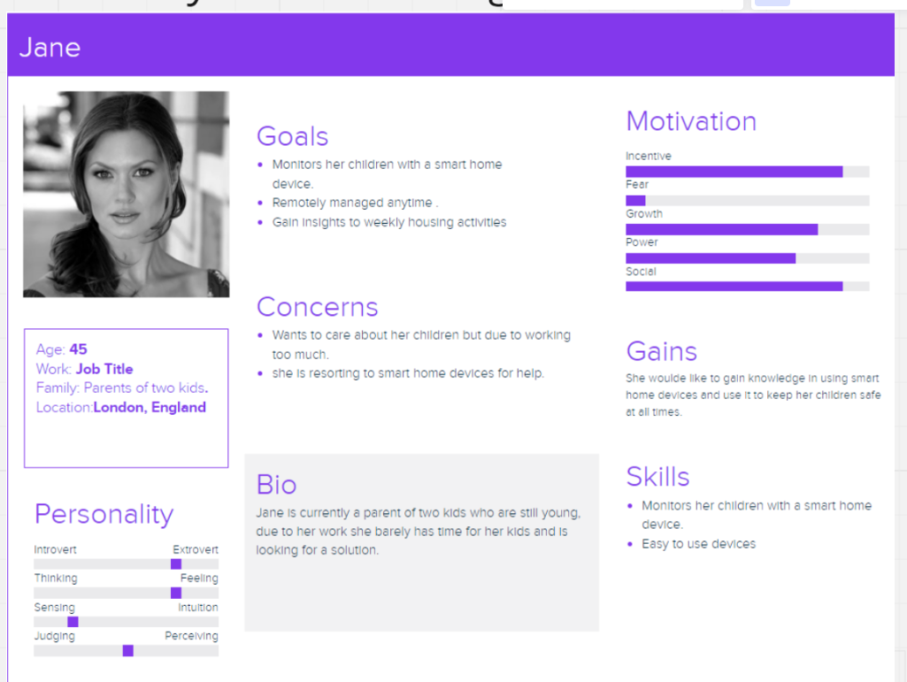

Appendix B:

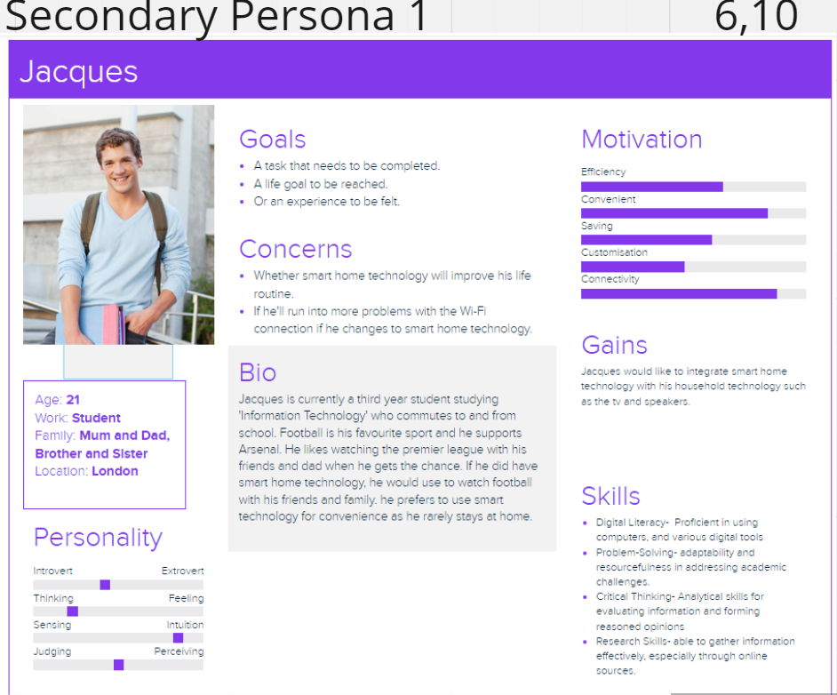

Appendix C:

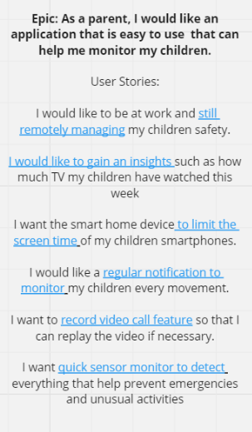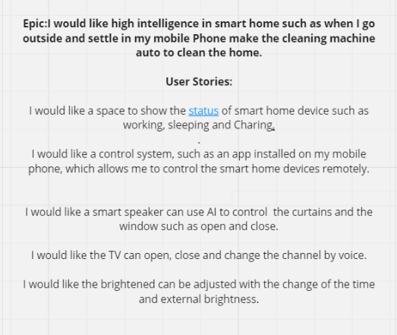

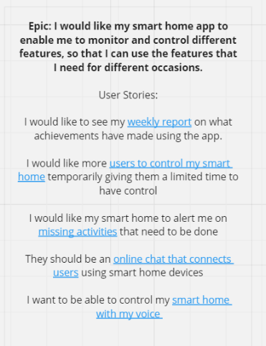

Appendix D:

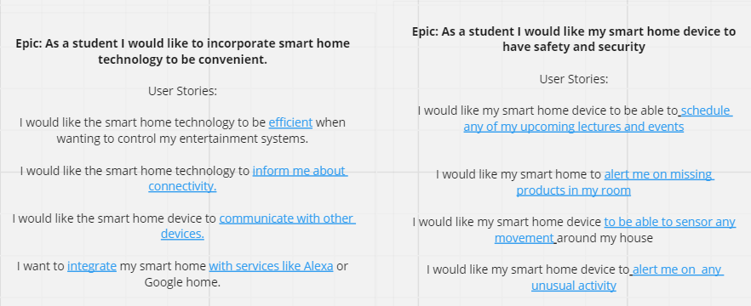

Appendix E:

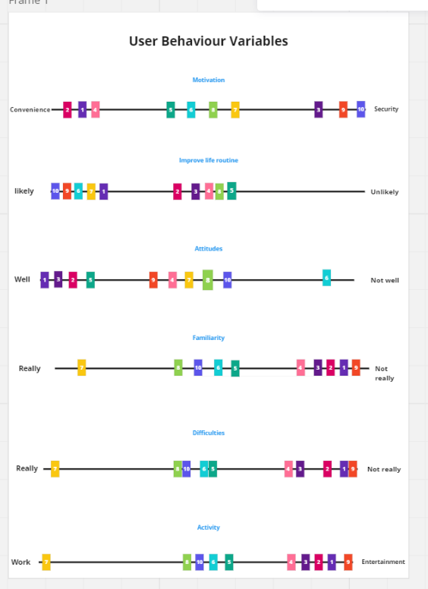

Appendix F:

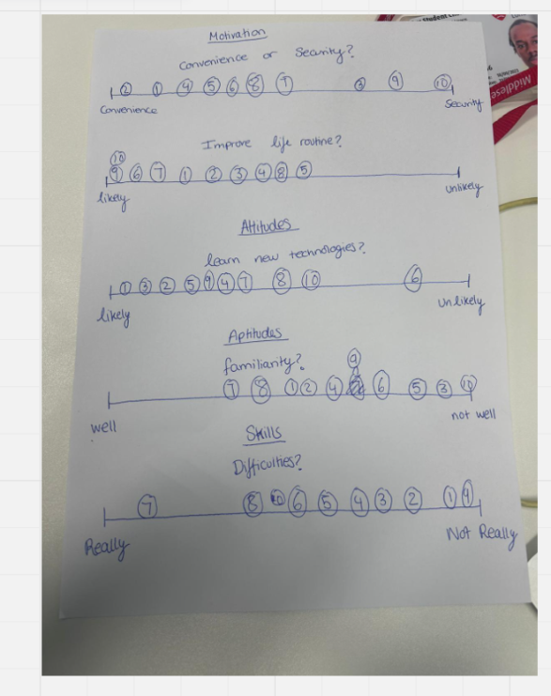

Appendix G:

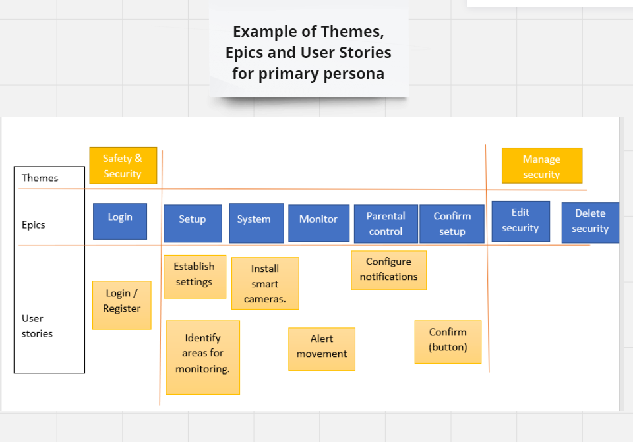

Appendix H:

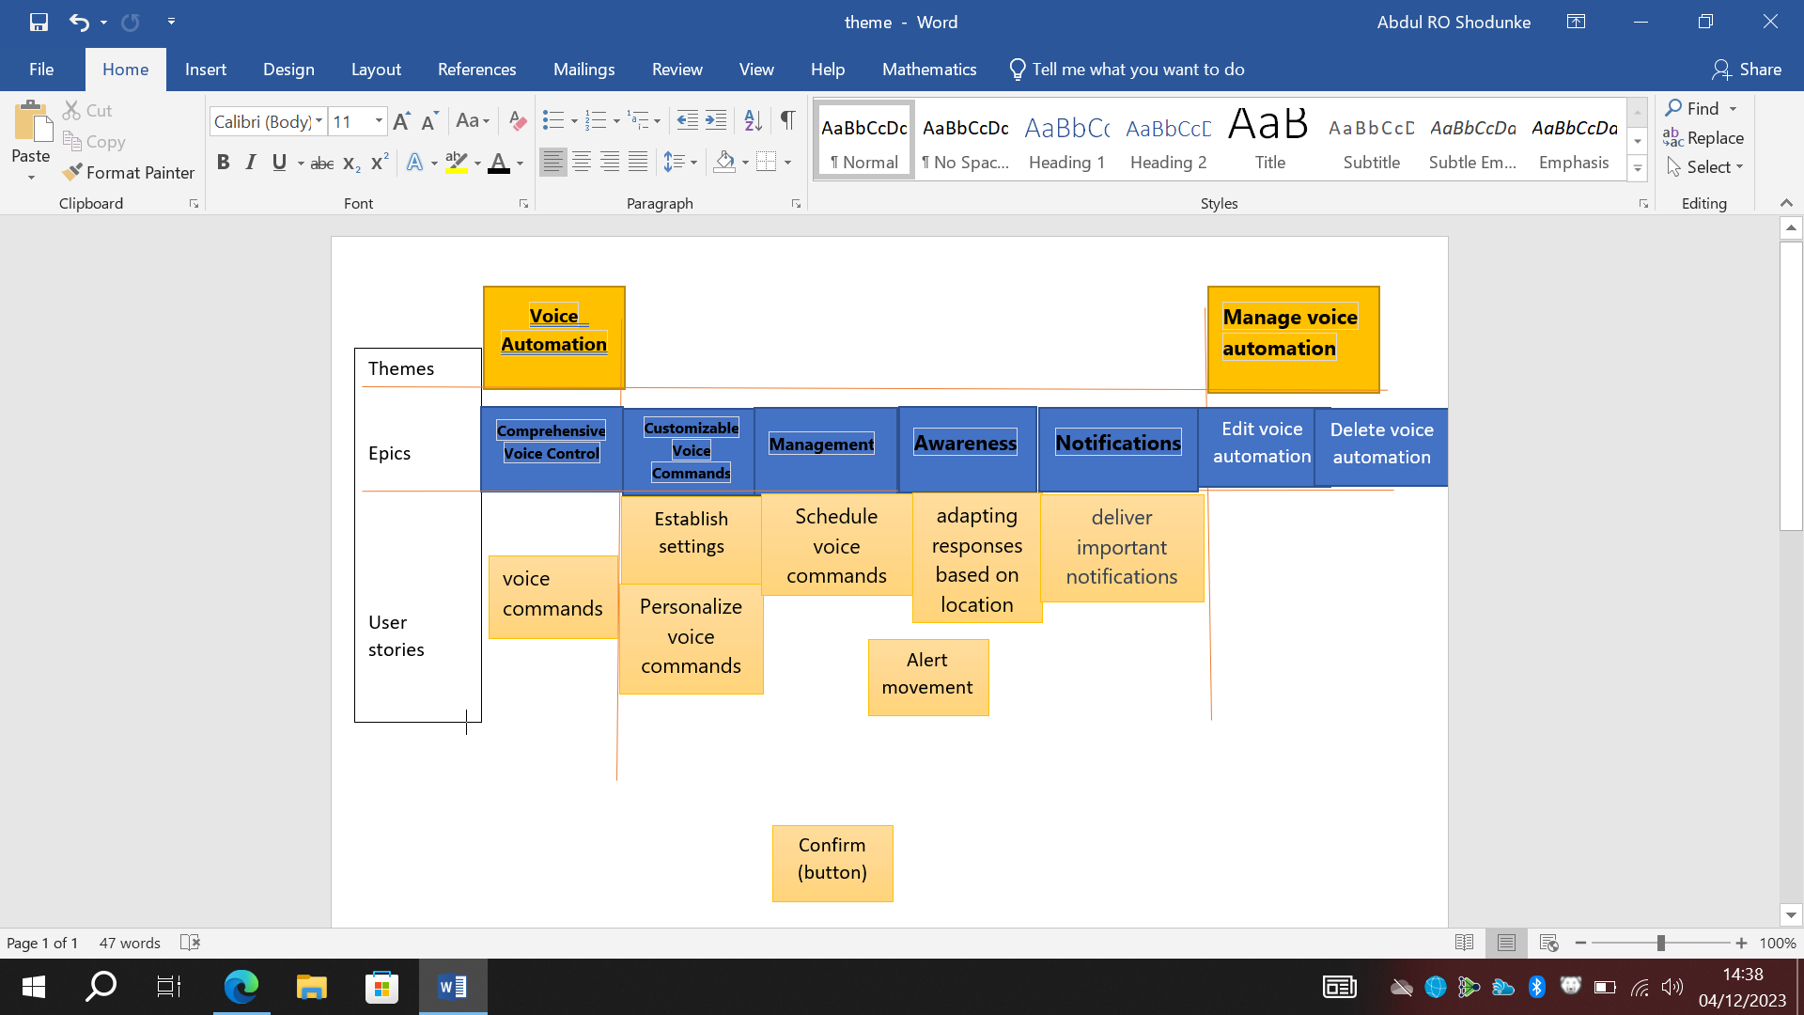

Appendix I:

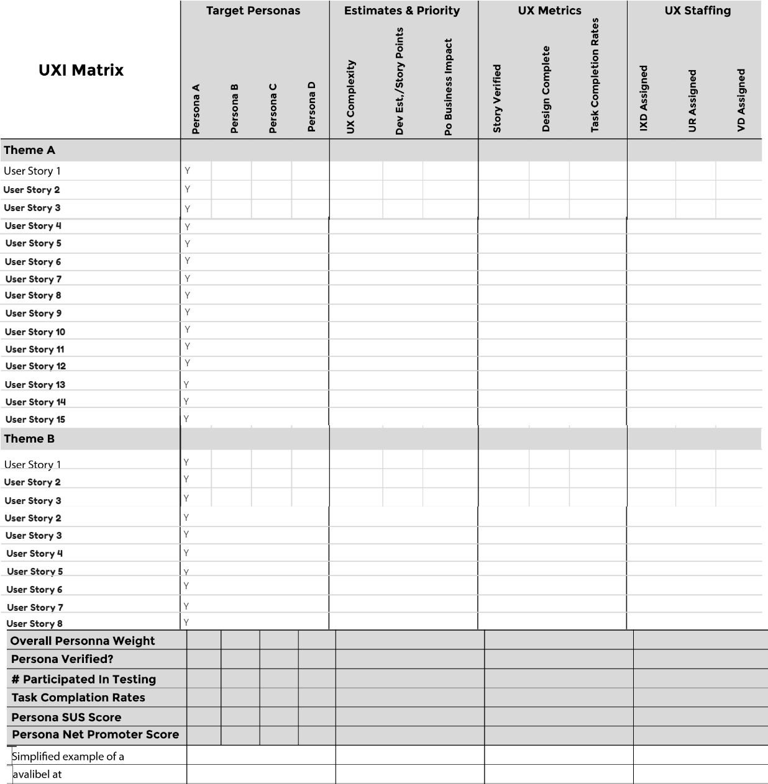

Appendix J: User Journey Primary Persona

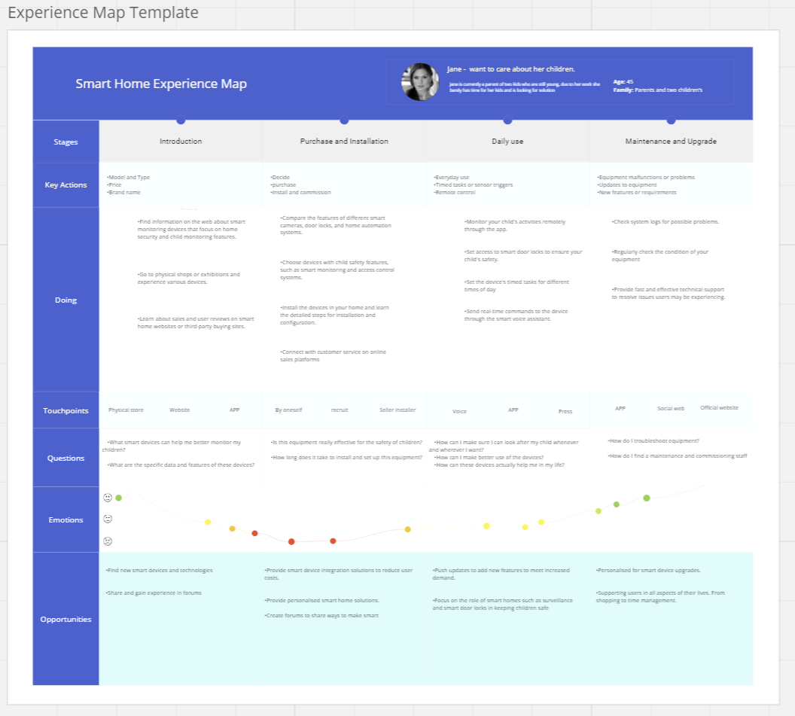

Appendix K: User Journey Secondary Persona

